# SANJALIKA WATERPARK SLIDE’S DESCRIPTION WITH MORE FEATURES



Figure sanjalika waterpark

Sanjalika Water Park is definitely an ultimate and out of the world source of entertainment. Decorated by mermaids, other statues, the Sanjalika Water park has largest cave and swimming pool area of modern technology a kind of place for thrills and fun. At Sanjalika Water park there is lot of water rides which are very exciting and thrilling.

In this document, you are gonna learn about more features of the slides with their information.

CONSTRICTOR SLIDE

Water parks are amusement parks that consist of lots of slides, playgrounds, swimming pools and lots of other areas which are full of water but are covered with various roundabouts. Water parks are mostly the favorite place to visit for every child and a lot of families during the summer visit various water parks as well. There are a lot of famous water parks around the world, and here a few of those water parks would be discussed where one can enjoy a **water park picnic** with his family.

FEATURES OF THE CONSTRICTOR SLIDE

Constrictor slide is a new type of water slide developed by Haisan in order to enrich the varieties of water amusement and bring new experience to tourists and improve the interest of family amusement. The height of the slide is 18.5m and the total length is nearly 200m, covering an area of about 3400m2, it looks like a huge Python circling there. This new type of water slide can carry 6 persons at the same time. Sitting on rafts and under the action of water and gravity, visitors slide down the inner wall of the slide and finally splash into the pool, experiencing an exciting journey.  
  
The unique design of Constrictor slide can bring visitors a variety of mixed sensory experience. There is no doubt that it is a shining star of modern water park.

MORE FEATURES

|  |  |
| --- | --- |
| **Diameter** | 3.0m-6.0m |
| **Capacity** | 6person/lane |
| **Tower height** | 18.5m |
| **Floor space** | 65m×35m |
| **Mats** | No |
| **Tube** | No |
| **Rafts** | Yes |
| **Production Method** | RTM |
| **Diameter** | 3.0m-6.0m |

CONSTRICTOR SLIDE IMAGES

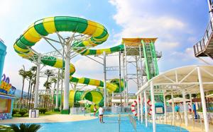

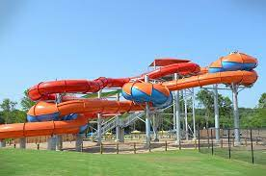

And many more images, customer feedback on such slides have always been good and keeps getting better.

Thank you!